Symbol Dictionary

While the modulation .run methods do create an array representing a modulated version of an input binary string, their performance is insufficient to be included in the main loop of a real-time audio processing program. Instead, in the channel simulation program, a symbol lookup dictionary is used to produce waveform arrays. Each 8-bit code word is generated and stored in a 256 element Python dictionary that is can be referenced using the 8-bit binary string, i.e. '00011011'. Use of the symbol lookup dictionary does not introduce any unrealistic characteristics into BPSK and QPSK modulations. However, the 2-MSK modulation is not accurately portrayed by the symbol lookup scheme. A genuine MSK modulation would have coherent phase across all symbols. Using the lookup dictionary introduces a phase discontinuity into successive symbols. The performance difference between using the .run method and lookup table, however, is on the order of 6000. In fact, the average time required by the .run method of the three modulations is 1ms, far exceeding the amount of time between samples from the audio interface, or 90μs.

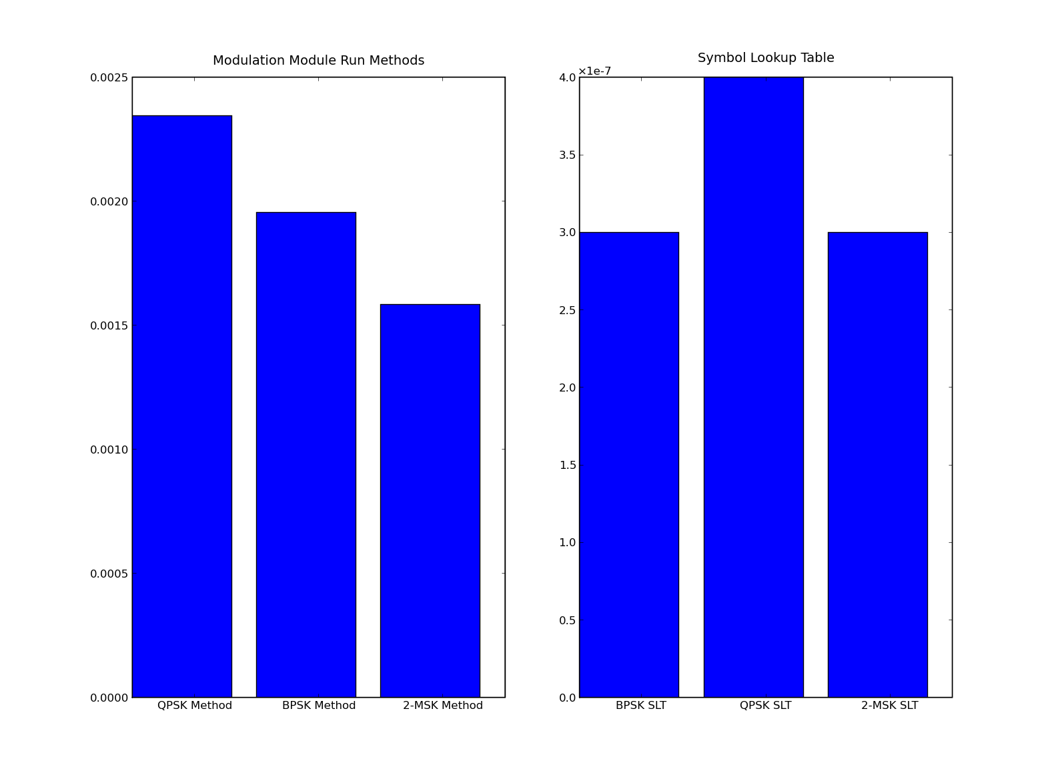Illustration 1: Result of 100K trials of the Run Methods and Symbol Lookup Table.
Usage:

from symboldict import *
slt = symbolLookupTable(pulsetype, modtype, samples, symperiod, alpha, frequency).symbolDict
outputarray = slt[binaryString]

pulsetype: Sets the pulse type, 'raisedCos' or 'rect'
modtype: Sets the modulation type 'bpsk', 'qpsk', or 'msk'
samples: Sets the number of samples per period of the modulated waveform
symperiod: Sets the bit period of the modulated waveform
alpha: Sets the alpha for raised cosine pulse shaped waveforms
frequency: Sets the carrier frequency for the modulated waveform

